## Technology

According to your requirements, React is a good choice. React is a popular JavaScript library known for its efficient rendering, component-based architecture, and vast ecosystem of libraries and tools. To further meet your requirements for minimalist code, speed, and ease of maintenance, here are some key points regarding React:

1. **Minimalist Code:**

* React promotes a declarative and component-based approach to building user interfaces, which leads to cleaner and more organized code.
* React components are modular and reusable, allowing you to create self-contained units of functionality with minimal code duplication.
* React's virtual DOM efficiently updates and renders only the necessary parts of the user interface, resulting in optimized and concise code.

**2. Fast:**

* React's virtual DOM efficiently updates and renders the UI by comparing the previous and current states, minimizing the number of actual DOM manipulations.
* React incorporates a diffing algorithm that optimizes the rendering process, resulting in faster updates and improved performance.
* React allows for efficient data flow and state management, enabling you to implement performance optimizations like memoization and lazy loading.

**3. Easy to Maintain:**

* React's component-based architecture promotes reusability and modularity, making it easier to maintain and update codebases.
* The unidirectional data flow in React ensures a clear and predictable flow of data, making it easier to debug and understand how changes propagate through the application.
* React has a large and active community that provides support, resources, and third-party libraries, making it easier to find solutions to common problems and stay up to date with best practices.

## Design

Great! We will proceed with using the CoreUI template as per your preference. It's a popular and feature-rich template that will provide a modern and professional design for your web application. We can leverage its pre-built components and customization options to create an interface that aligns with your project's branding. Thank you for your input, and I will ensure to implement the CoreUI template effectively in the development process.

However, please **note** that the free CoreUI template doesn't include built-in functionality for **sorting, filtering, and pagination in tables**. But not to worry! We will develop these features as custom solutions specifically tailored to your requirements.

Based on the provided project description, here is a proposal for the implementation:

1. **CoreUI template integration:**
2. **CoreUI template**
3. **API Integration**
4. **Security**
5. **login.html:**
   * Create a login page with two textboxes and button.
   * Add a button that, when clicked, will authenticate the user by calling an API.

6. **index.html:**

* + This page will be used later in the project and currently remains empty.

7. **project_index.html:**

* + Implement a page to list all projects.
  + Display the latest created projects in a grid format.
  + Include columns for project details such as title, code, category, business sector, age group, language, gender, host, domain, theme, description, and a button for further actions.

8. **project_edition.html:**

* + Create a page for creating or editing project information.
  + Determine whether the page is in creation mode or edit mode based on the existence of the project (determined by an API call).
  + Include input fields or dropdowns for each property of the project model, including title, code, category, business sector, age group, language, gender, host, domain, theme, and description.
  + Add a "SEND" button that will trigger an API call to either create or update the project based on the mode.

FOR backend deployment on local iis you can also run this application on your local system as well

Step 1:

Set connection string in your project class ConnectionHelper

Step 2: Add website in IIS

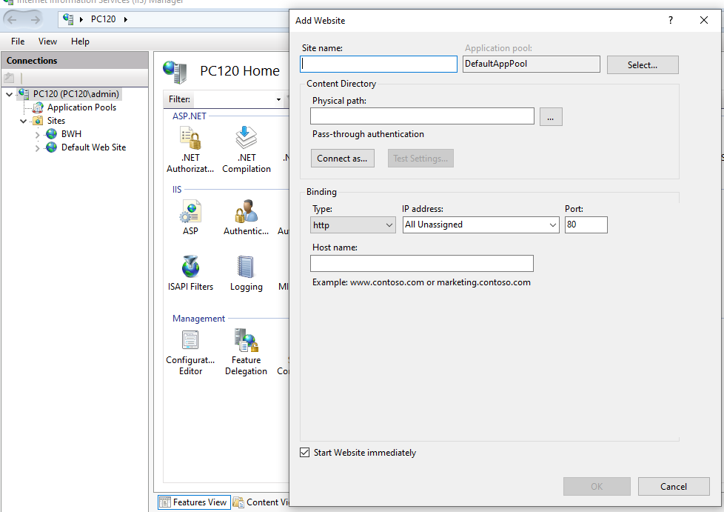

i-Write name

ii-Physical address try to give below path 🡪 C:\inetpub\wwwroot



iii-port 8082

After that publish from visual studio application to=> C:\inetpub\wwwroot

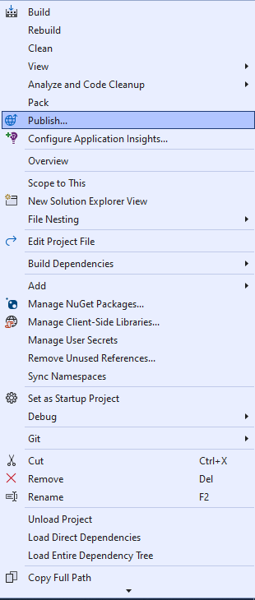

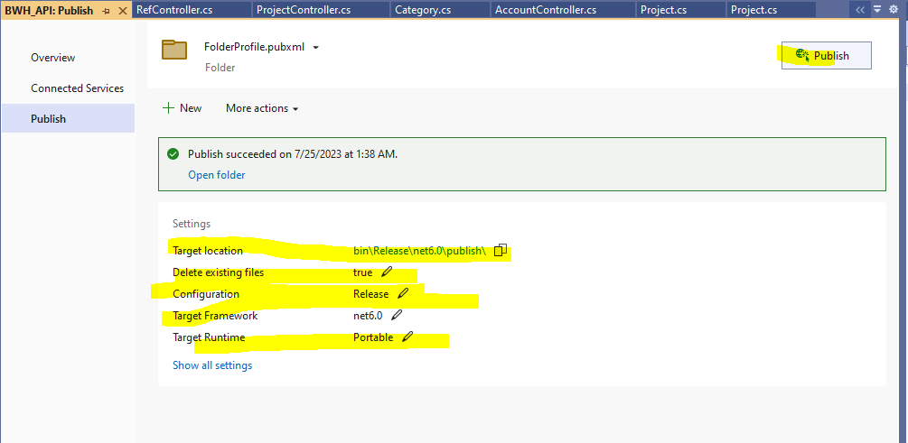

Set the above settings and click publish your application is published

**For front end**

Open project in vs code

In the terminal run these commands below

1. Yarn install
2. Yarn start